Course Name: | Web Programming Laboratory (216U01L405) | Semester: | IV
Date of Performance: | 23/01/2026 | DIV/ Batch No: | B2
Student Name: | Prathamesh Sanjeev Jadhav | Roll No: | 16010124109

Experiment No: 1
Title: Design web Portal using CSS3.

Aim of the Experiment: To apply CSS3 style sheets to an existing HTML5-based Web Portal in order to enhance layout, responsiveness, visual aesthetics, and user interaction using modern CSS3 features.

Objectives for the Experiment:
- Implement different CSS3 styling techniques
- Design responsive layouts using Flexbox and media queries
- Enhance user interaction using animations
- Maintain separation of content and presentation

COs to be achieved:
CO1: Use CSS to prepare the layout of web pages.

Books/ Journals/ Websites references:
- Students should write

Theory:
Students should write about CSS3 (citation needed for content taken (IEEE or APA7 style))

Problem statement: “College Event & Student Services Web Portal” A college wants to develop a basic HTML5-based web portal to showcase events, registrations, information, and services for students. Each task contributes one page or feature of this portal. Enhanced the portal using CSS3.
Task 1: Home Page Styling – CSS Selectors & Properties
Use Case:
Improve the Home Page appearance of the portal.
CSS Requirements:
- Apply element, class, and ID selectors
- Style headings, paragraphs, and navigation links
- Use background color, font-family, and text alignment
- Add hover effect to navigation links
Deliverable: style.css linked to index.html
CSS Concepts: Selectors, basic properties

Task 2: Event Page – Text Styling & Fonts
Use Case:
Enhance readability of the TechFest Event Details page.
CSS Requirements:
- Use different fonts for headings and content
- Apply text properties (color, letter-spacing, line-height)
- Style highlighted text (<mark>, <strong>)
- Use Google Fonts (optional)
Deliverable: event.css linked to event-details.html
CSS Concepts: Fonts, text formatting

Task 3: Department Page – Box Model
Use Case:
Visually organize the About Department sections.
CSS Requirements:
- Apply margin, padding, and border to each section
- Add box-shadow to HoD message block
- Demonstrate content-box or border-box
Deliverable: boxmodel.css linked to about-dept.html
CSS Concepts: Box model

Task 4: Clubs Page – Lists & Pseudo-Classes
Use Case:
Make Student Clubs list visually attractive.
CSS Requirements:
- Remove default bullets and numbers
- Add custom list styling
- Use :hover, :first-child, :last-child
- Highlight nested lists differently
Deliverable: clubs.css linked to clubs.html
CSS Concepts: List styling, pseudo-classes

Task 5: Navigation – CSS Layout (Flexbox)
Use Case:
Design a horizontal navigation bar.
CSS Requirements:
- Use Flexbox for layout
- Align menu items horizontally
- Add spacing and hover effects
- Make navigation bar sticky
Deliverable: nav.css linked to navigation.html
CSS Concepts: Flexbox, positioning

Task 6: Campus Map – Image Styling & Positioning
Use Case:
Improve visual presentation of Campus Map page.
CSS Requirements:
- Make image responsive
- Center image on page
- Add border and shadow
- Style captions using CSS
Deliverable: map.css
CSS Concepts: Images, positioning, responsiveness

Task 7: Results Page – Table Styling
Use Case:
Enhance Event Results Table readability.
CSS Requirements:
- Add border-collapse
- Alternate row colors (zebra striping)
- Style table header and footer
- Highlight row on hover
Deliverable: table.css
CSS Concepts: Table styling

Task 8: Registration Form – Form Styling
Use Case:
Improve user experience of Event Registration Form.
CSS Requirements:
- Align labels and inputs
- Style text fields, buttons, dropdowns
- Use focus effects on inputs
- Style submit and reset buttons differently
Deliverable: form.css
CSS Concepts: Forms, pseudo-classes

Task 9: Responsive Design – Media Queries
Use Case:
Make portal usable on mobile devices.
CSS Requirements:
- Use media queries for mobile view
- Stack navigation items vertically on small screens
- Resize images and text for mobile
- Hide non-essential content on small screens
Deliverable: responsive.css
CSS Concepts: Responsive design, media queries

Code:
- Home Page Styling
- Index.html:
<!DOCTYPE html>
<html>
<head>
<title>College Event Portal</title>
<link rel="stylesheet" href="style.css">
</head>
<body>

<div id="home" class="container" style="text-align:center;">

<img src="KJSCE.webp" alt="logo">

<h2 class="logo" title="Official College Event Portal">COLLEGE EVENT PORTAL</h2>

<h1 id="clgname" title="Welcome to KJSSE">K. J. Somaiya School of Engineering</h1>

<p class="year">Academic Year: 2025 – 2026</p>

</div>

</body>
</html>
- Style.css:
body {
font-family: Arial, Helvetica, sans-serif;
background-color: #f4f6f8;
margin: 0;
}

#home-header {
background-color: #003366;
color: white;
text-align: center;
padding: 20px;
}

.intro {
font-size: 18px;
text-align: center;
color: #333;
}

nav a {
color: white;
margin: 0 15px;
text-decoration: none;
}

nav a:hover {
color: #ffcc00;
text-decoration: underline;
}
- Event Page Text & Fonts
- Event-details:
<!DOCTYPE html>
<html>
<head>
<title>Event Details</title>
<link rel="stylesheet" href="event.css">
</head>
<body>

<table style="width:100%">
<tr>
<td>
<img src="KJSCE.webp" alt="logo" style="text-align:left;">
</td>

<td style="width:100%">
<div id="home" class="container" style="text-align:center;">
<h1><strong><mark>Abhiyantriki</mark></strong></h1>

<p><strong><mark>Abhiyantriki</mark></strong> is the biggest technical event of our college.</p>

<p>The main theme of the event is <em>Innovation and Future Technology</em>.</p>

<p>The event will be held on 15<sup>th</sup> August 2026.</p>

<p>This is version 2<sub>0</sub> of the TechFest.</p>

<p>Workshops will be conducted on <abbr title="Artificial Intelligence">AI</abbr>, <abbr title="Internet of Things">IoT</abbr>, and <abbr title="Machine Learning">ML</abbr>.</p>

<p><small>Event schedule may change without prior notice.</small></p>
</td>
</tr>
</table>

<img src="campus.jpg" alt="Campus Photo" style="width:100%;">
</div>
</body>
</html>
- Event.css:
@import url('https://fonts.googleapis.com/css2?family=Poppins&family=Roboto&display=swap');

body {
font-family: 'Roboto', sans-serif;
}

h1, h2 {
font-family: 'Poppins', sans-serif;
color: #1a237e;
letter-spacing: 1px;
}

p {
line-height: 1.6;
color: #333;
}

mark {
background-color: #fff59d;
padding: 2px 4px;
}

strong {
color: #d32f2f;
}

- Department Page
- About-dept.html
<!DOCTYPE html>
<html lang="en">

<head>
<meta charset="UTF-8">
<title>About Cardiology</title>
<link rel="stylesheet" href="boxmodel.css">
</head>

<body>
<h1>Department of Cardiology</h1>
<section>
<h3>Message from the Chief</h3>
<blockquote>
"The heart is the engine of life, and we are here to keep it running smoothly."
</blockquote>
</section>
<div>
<h3>Vision</h3>
<p>To be a <b>global leader</b> in cardiac care.</p>
</div>
<div>
<h3>Mission</h3>
<p>To provide <i>affordable</i> and <b>advanced</b> heart treatments.</p>
</div>
<div>
<h3>Facilities</h3>
<p>Angiography, Pacemaker Implantation, 24/7 ECG monitoring.</p>
</div>
</body>

</html>

- Boxmodel.css:
.section {
margin: 20px;
padding: 15px;
border: 2px solid #ccc;
box-sizing: border-box; /* border-box demo */
background-color: #fafafa;
}

.hod-message {
box-shadow: 0 4px 10px rgba(0,0,0,0.2);
border-left: 5px solid #1976d2;
}

- Clubs Page
- Clubs.html
<!DOCTYPE html>
<html lang="en">

<head>
<meta charset="UTF-8">
<title>Doctors & Departments</title>
<link rel="stylesheet" href="clubs.css">
</head>

<body>
<h1>Our Departments</h1>
<h3>Medical Departments</h3>
<ol type="1">
<li>
Cardiology
<ul>
<li>Dr. A. Sharma</li>
<li>Dr. B. Patel</li>
</ul>
</li>
<li>
Neurology
<ul>
<li>Dr. C. Rao</li>
</ul>
</li>
<li>Orthopedics</li>
</ol>
<h3>Support Services</h3>
<ul type="square">
<li>Ambulance</li>
<li>Pharmacy</li>
<li>Blood Bank</li>
</ul>
<h3>Department Abbreviations</h3>
<dl>
<dt>OPD</dt>
<dd>Out Patient Department For routine checkups.</dd>
<dt>ENT</dt>
<dd>Ear, Nose, and Throat specialists.</dd>
</dl>
</body>

</html>

- Clubs.css
ul {
list-style: none;
padding-left: 0;
}

li {
padding: 10px;
background-color: #e3f2fd;
margin-bottom: 8px;
}

li:hover {
background-color: #bbdefb;
}

li:first-child {
font-weight: bold;
}

li:last-child {
font-style: italic;
}

li ul li {
background-color: #f1f8e9;
}

- Navigation
- Navigation.html:
<!DOCTYPE html>
<html lang="en">

<head>
<meta charset="UTF-8">
<title>Site Navigation</title>
<link rel="stylesheet" href="nav.css">
</head>

<body>
<h1>Portal Navigation</h1>
<h3>Internal Links</h3>
<nav>
<ul>
<li><a href="index.html">Home</a></li>
<li><a href="services.html">Services</a></li>
<li><a href="about-department.html">About Cardiology</a></li>
<li><a href="doctors.html">Doctors & Departments</a></li>
<li><a href="hospital-map.html">Hospital Layout</a></li>
<li><a href="appointments.html">Appointments List</a></li>
<li><a href="book-appointment.html">Book Appointment</a></li>
<li><a href="media.html">Media Page</a></li>
</ul>
</nav>
<h3>External Resources</h3>
<ul>
<li><a href="https://www.mohfw.gov.in/" target="_blank">Ministry of Health (Govt)</a></ li>
</ul>
<h3>Contact Us</h3>
<ul>
<li>Email: <a href="mailto: appointment@somaiyahospital.
com">appointment@somaiyahospital.com</a></li>
<li>Emergency: <a href="tel:+911234567890">+91 12345 67890</a></li>
</ul>
</body>

</html>

- Nav.css:
nav {
display: flex;
justify-content: center;
gap: 20px;
background-color: #263238;
position: sticky;
top: 0;
padding: 15px;
}

nav a {
color: white;
text-decoration: none;
}

nav a:hover {
color: #4fc3f7;
}

- Campus Map
- campus-map.html
<!DOCTYPE html>
<html lang="en">

<head>
<meta charset="UTF-8">
<title>Hospital Map</title>
<link rel="stylesheet" href="map.css">
</head>

<body id="page-map">
<h1>Interactive Hospital Layout</h1>
<p style="text-align:center;">Click on the areas in the image (Left:Emergency, Right: Pharmacy).</p>
<div class="map-wrapper">
<img src="https://i.pinimg.com/736x/83/c9/22/83c922df6ceefd6e98bc5775ee57edff.jpg
" alt="Hospital Layout" usemap="#hospitalmap">
<p style="font-style: italic; color: #666; margin-top: 10px;">Fig.1:
Ground Floor Plan</p>
</div>
<map name="hospitalmap">
<area shape="rect" coords="0,0,300,400" href="services.html" alt="Emergency Ward"
title="Go to Emergency Services">
<area shape="rect" coords="300,0,600,400" href="doctors.html" alt="Pharmacy" title="Go to Pharmacy Info">
</map>
</body>

</html>

- map.css
#page-map h1 { text-align: center; }
#page-map .map-wrapper {
text-align: center;
margin: 20px auto;
}
#page-map img {
max-width: 100%;
height: auto;
border: 5px solid #fff;
box-shadow: 0 10px 20px rgba(0,0,0,0.3);
display: block;
margin: 0 auto;
}

- Results Page
- Results.html
<!DOCTYPE html>
<html lang="en">

<head>
<meta charset="UTF-8">
<title>Daily Appointments</title>
<link rel="stylesheet" href="tables.css">
</head>

<body>
<h1>Daily Appointment Summary</h1>
<table border="1">
<caption>List of Today's Scheduled Visits</caption>
<thead>
<tr>
<th colspan="4">February 24, 2025</th>
</tr>
<tr>
<th>Patient Name</th>
<th>Doctor</th>
<th>Time</th>
<th>Status</th>
</tr>
</thead>
<tbody>
<tr>
<td>John Doe</td>
<td>Dr. Sharma</td>
<td>10:00 AM</td>
<td>Completed</td>
</tr>
<tr>
<td>Jane Smith</td>
<td>Dr. Patel</td>
<td>11:30 AM</td>
<td>Waiting</td>
</tr>
</tbody>
<tfoot>
<tr>
<tfoot>
<tr>
<td colspan="4">Total Appointments: 2</td>
</tr>
</tfoot>
</table>
</body>

</html>

- Tables.css
table {
width: 100%;
border-collapse: collapse;
}

th, td {
border: 1px solid #aaa;
padding: 10px;
text-align: center;
}

thead {
background-color: #1976d2;
color: white;
}

tfoot {
background-color: #eeeeee;
font-weight: bold;
}

tbody tr:nth-child(even) {
background-color: #f2f2f2;
}

tbody tr:hover {
background-color: #bbdefb;
}

- Registration
- Register.html
<!DOCTYPE html>
<html lang="en">

<head>
<meta charset="UTF-8">
<title>Book Appointment</title>
<link rel="stylesheet" href="form.css">
</head>

<body>
<h1>Book an Appointment</h1>
<form action="submit appointment.php" method="post">
<label for="pname">Patient Name: </label><br>
<input type="text" id="pname" name="pname" required><br><br>
<label for="email">Email:</label><br>
<input type="email" id="email" name="email" required><br><br>
<label for="phone">Contact Number: </label><br>
<input type="tel" id="phone" name="phone"><br><br>
<label for="dept">Department: </label><br>
<select id="dept" name="dept">
<option value="cardio">Cardiology</option>
<option value="neuro">Neurology</option>
<option value="ortho">Orthopedics</option>
</select><br><br>
<label>Gender: </label><br>
<input type="radio" id="male" name="gender" value="male">
<label for="male">Male</label>
<input type="radio" id="female" name="gender" value="female">
<label for="female">Female</label><br><br>
<label>Symptoms:</label><br>
<input type="checkbox" id="fever" name="symptom" value="fever">
<label for="fever">Fever</label>
<input type="checkbox" id="cough" name="symptom" value="cough">
<label for="cough">Cough</label><br><br>
<label for="fever">Fever</label>
<input type="checkbox" id="cough" name="symptom" value="cough">
<label for="cough">Cough</label><br><br>
<input type="submit" value="Book Now">
<input type="reset" value="Clear Form">
</form>
</body>

</html>

- Form.css
form {
width: 50%;
margin: auto;
}

label {
display: block;
margin-top: 15px;
}

input, select {
width: 100%;
padding: 8px;
margin-top: 5px;
}

input:focus, select:focus {
outline: none;
border: 2px solid #1976d2;
}

button[type="submit"] {
background-color: #4caf50;
color: white;
padding: 10px;
margin-top: 15px;
}

button[type="reset"] {
background-color: #f44336;
color: white;
padding: 10px;
margin-left: 10px;
}

- Responsive Design
- Media.html
<!DOCTYPE html>
<html lang="en">

<head>
<meta charset="UTF-8">
<title>Media Gallery</title>
<link rel="stylesheet" href="responsive.css">
</head>

<body>
<h1>Hospital Media & Location</h1>
<h3>Introductory Video</h3>
<video width="400" controls>
<source src="https://www.w3schools.com/html/mov_bbb.mp4" type="video/mp4">
Your browser does not support the video tag.
</video>
<h3>Audio</h3>
<audio controls>
<source src="https://www.w3schools.com/html/horse.mp3" type="audio/mpeg">
Your browser does not support the audio element.
</audio>
<h3>Our Location</h3>
<iframe
src="https://www.google.com/maps/embed?pb=!1m18!1m12!1m3!1d3770.819793138379!2d72.89728631490104!3d19.071661987090336!2m3!1f0!2f0!3f0!3m2!1i1024!2i768!4f13.1!3m3!1m2!1s0x3be7c627a20baf93%3A0xeb664393b589412e!2sK.%20J.%20Somaiya%20College%20of%20Engineering!5e0!3m2!1sen!2sin!4v1645000000000!5m2!1sen!2sin"
width="400" height="300" loading="lazy">
</iframe>
<noscript>
<p>Your browser does not support JavaScript or it is disabled. Some
features may not work.</p>
</noscript>
</body>

</html>

- Responsive.css
@media (max-width: 768px) {

nav {
flex-direction: column;
align-items: center;
}

body {
font-size: 14px;
}

img {
width: 100%;
height: auto;
}

.desktop-only {
display: none;
}
}

Output / Screenshot:
- Home Page Styling
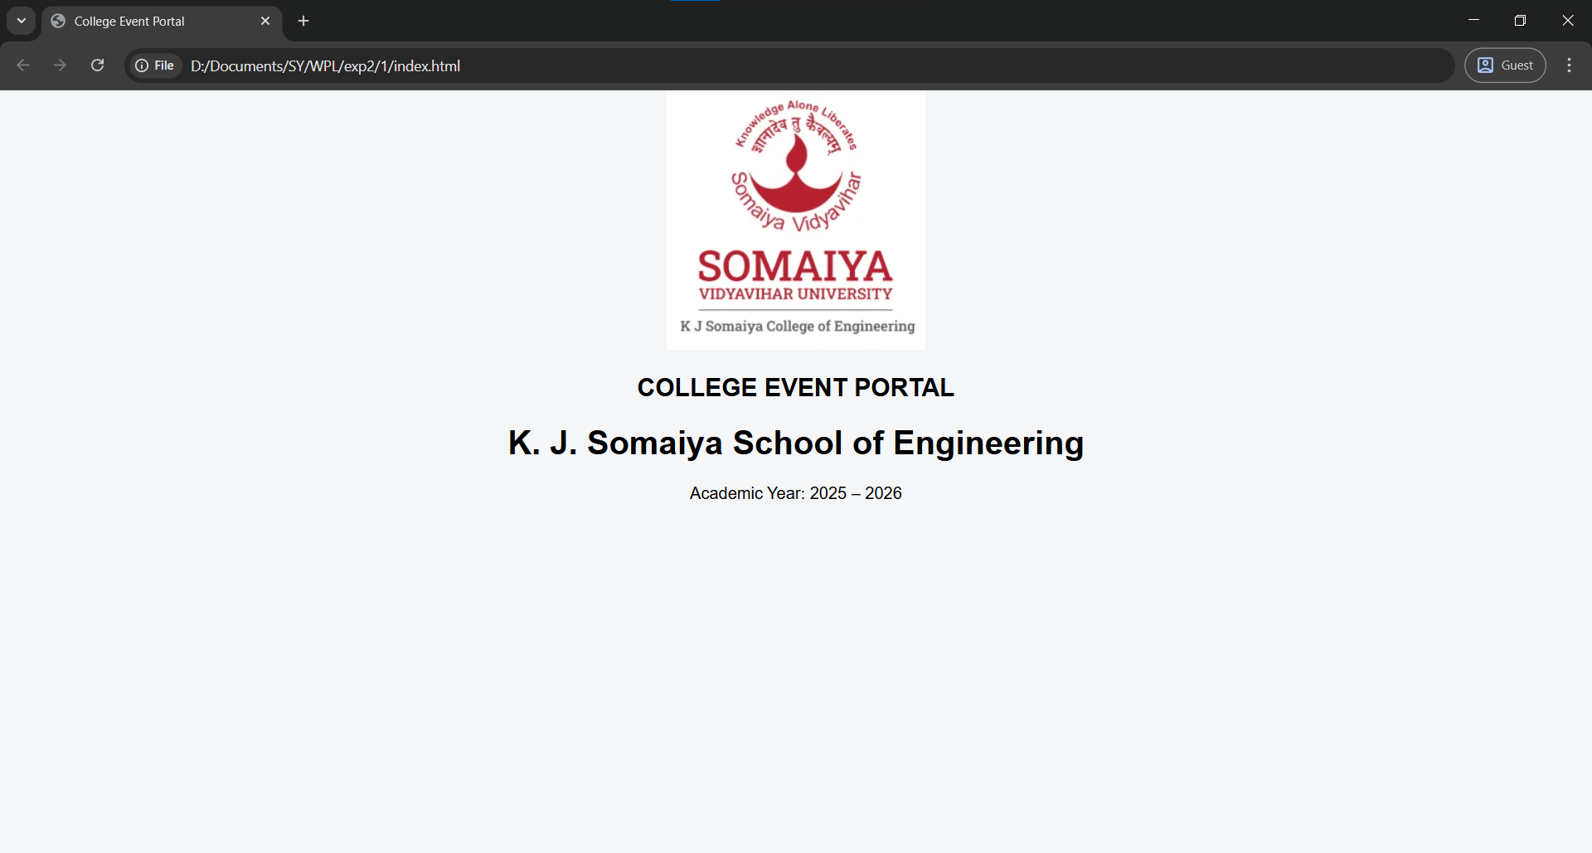
- Event Page Text & Fonts
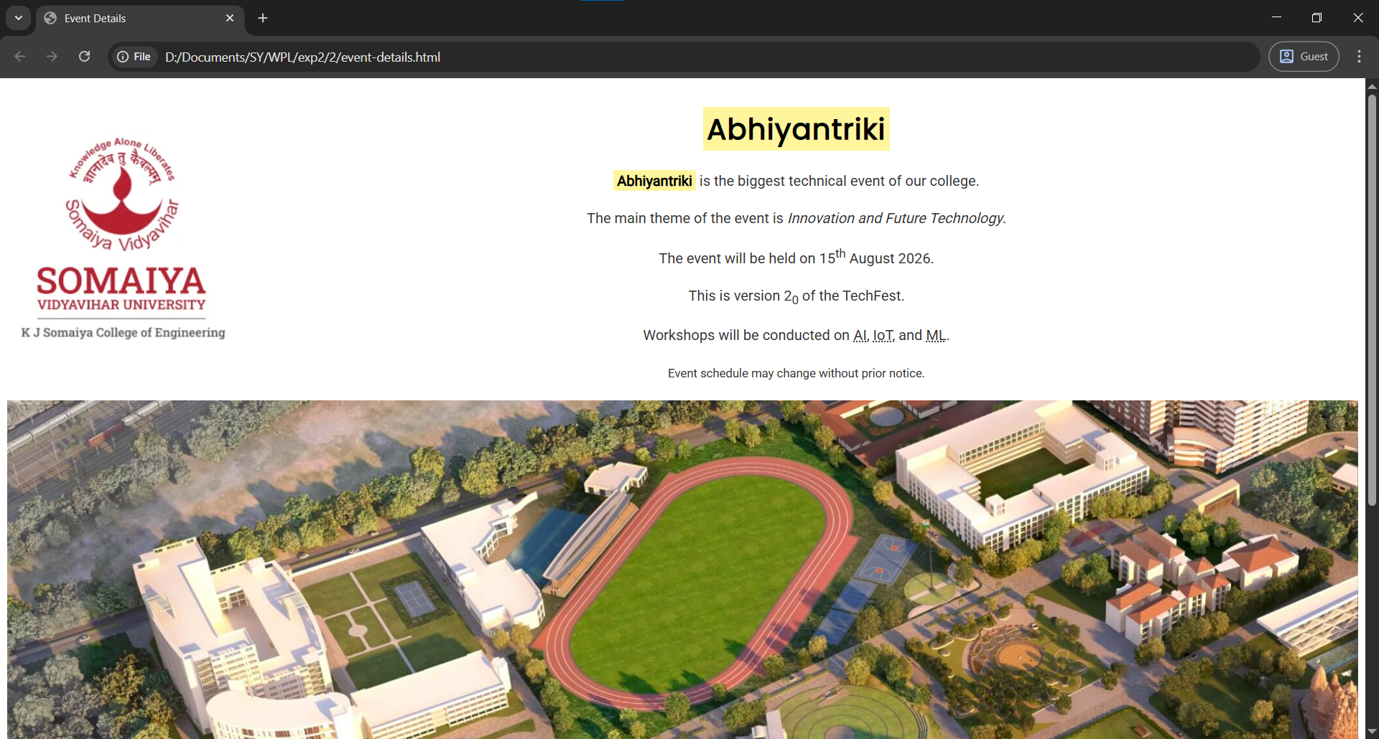
- Department Page
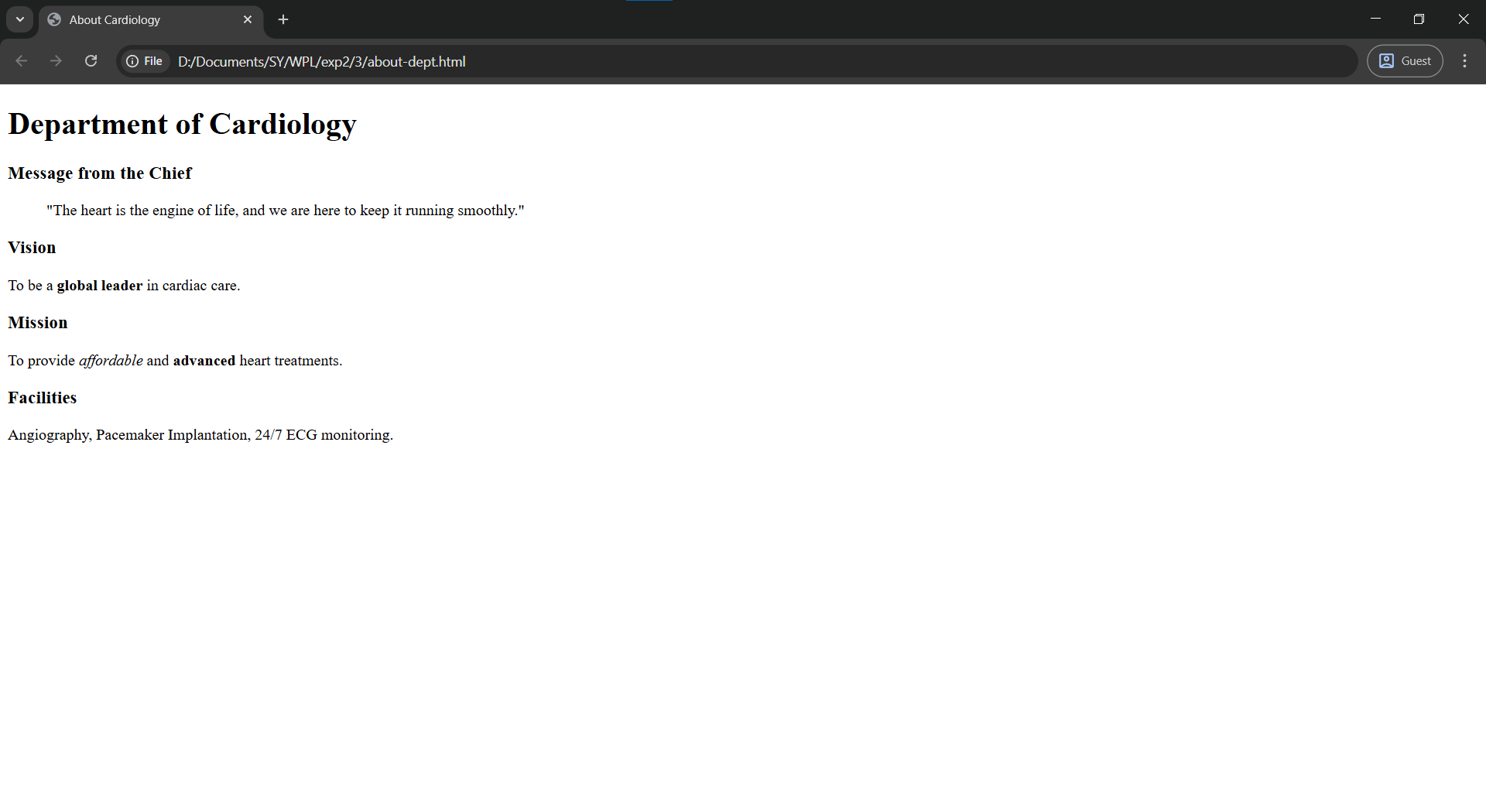
- Clubs Page
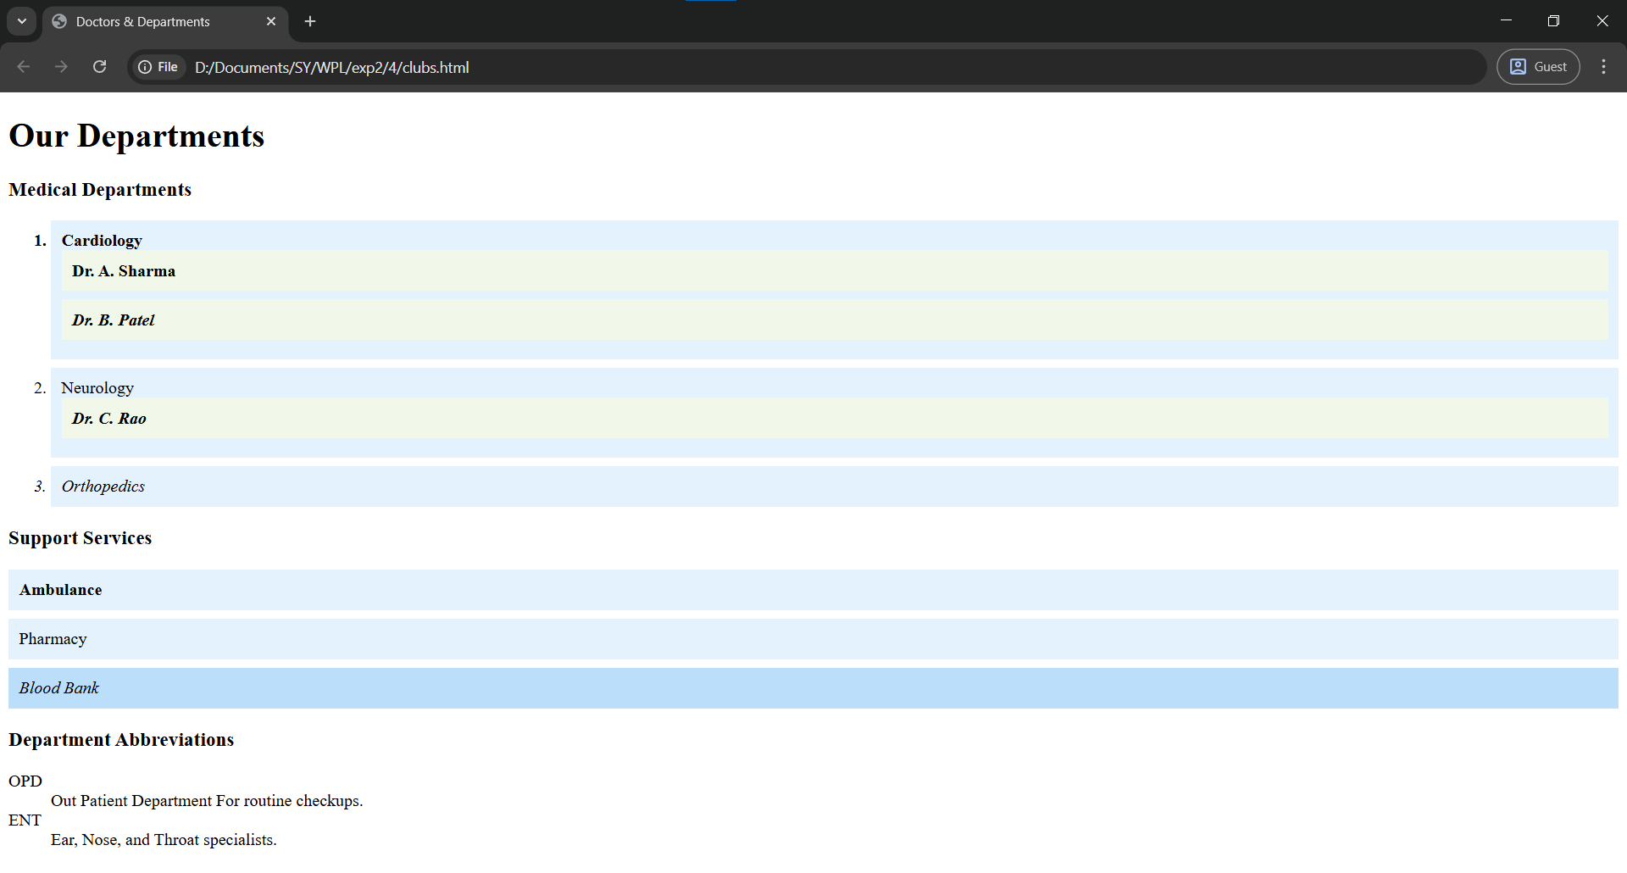
- Navigation
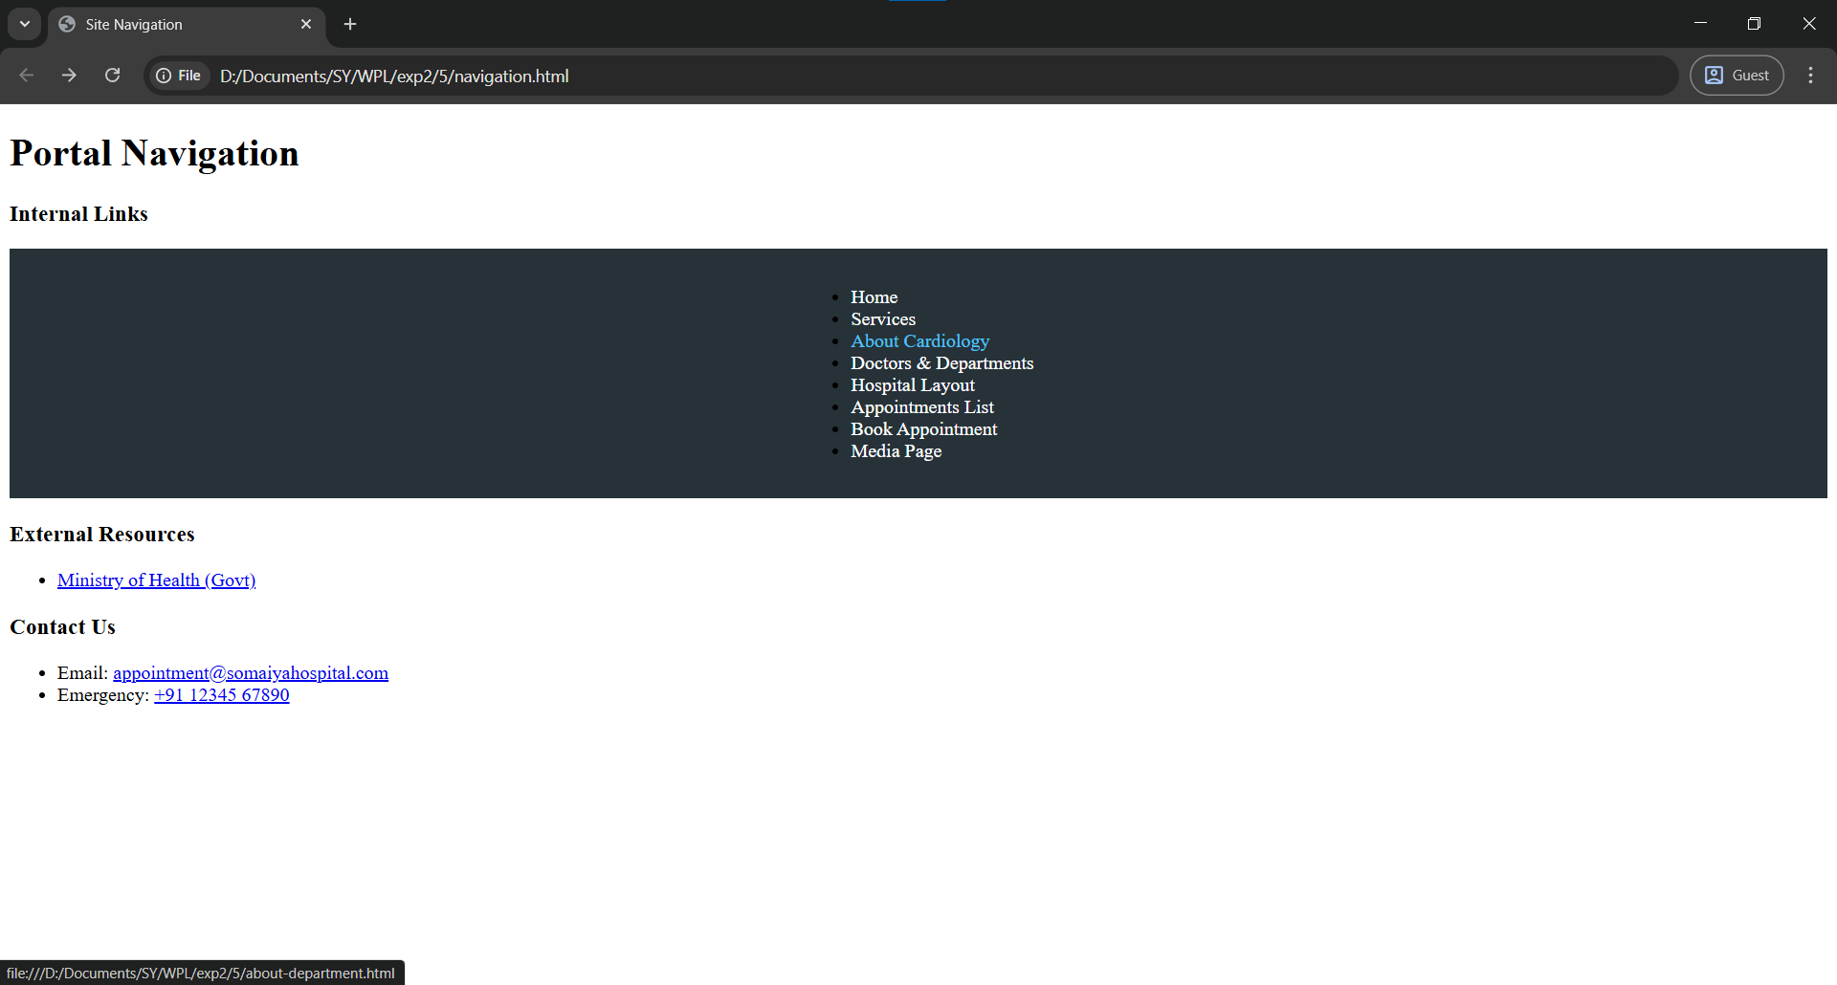
- Campus Map
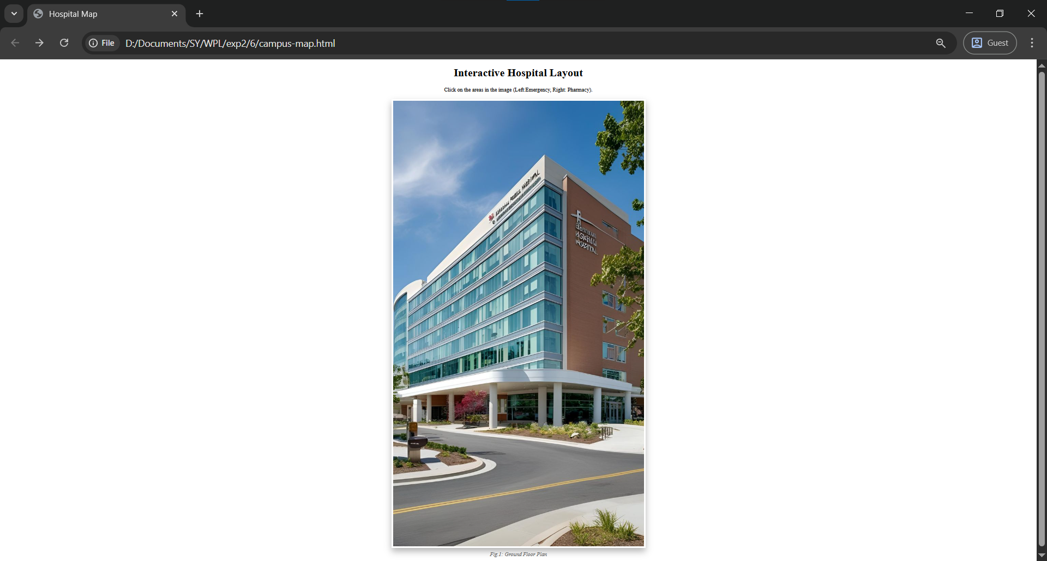
- Results Page
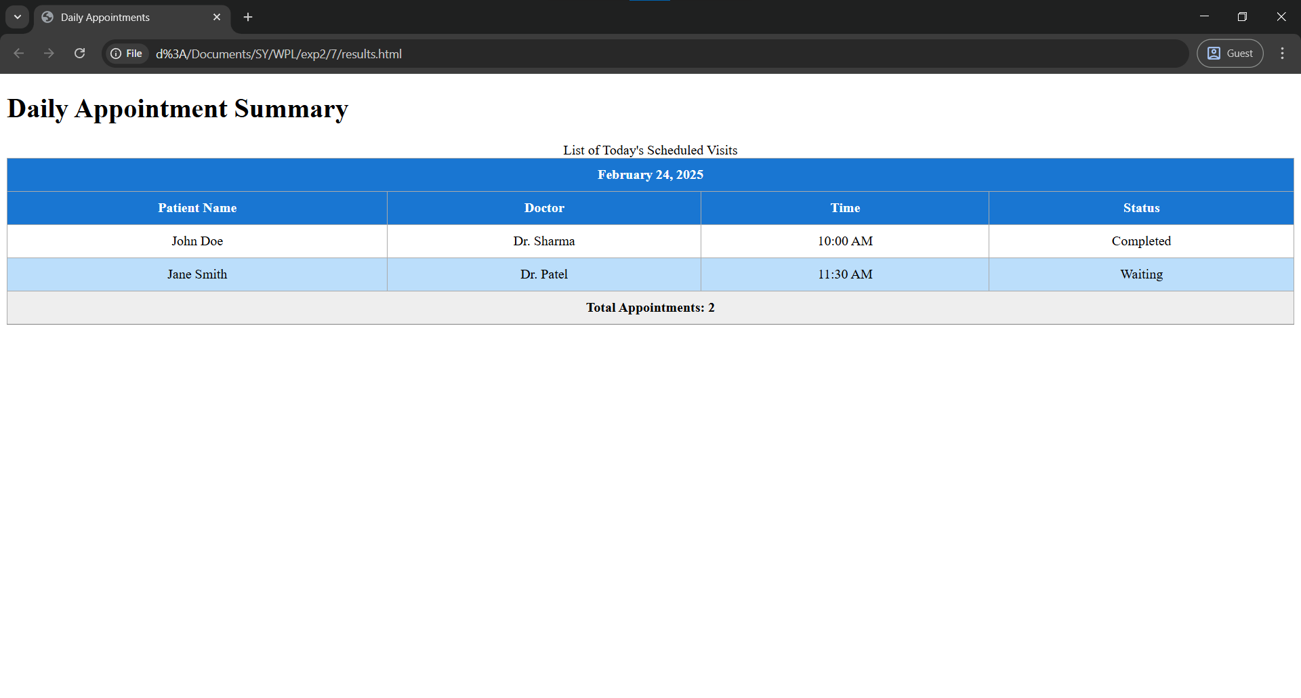
- Registration
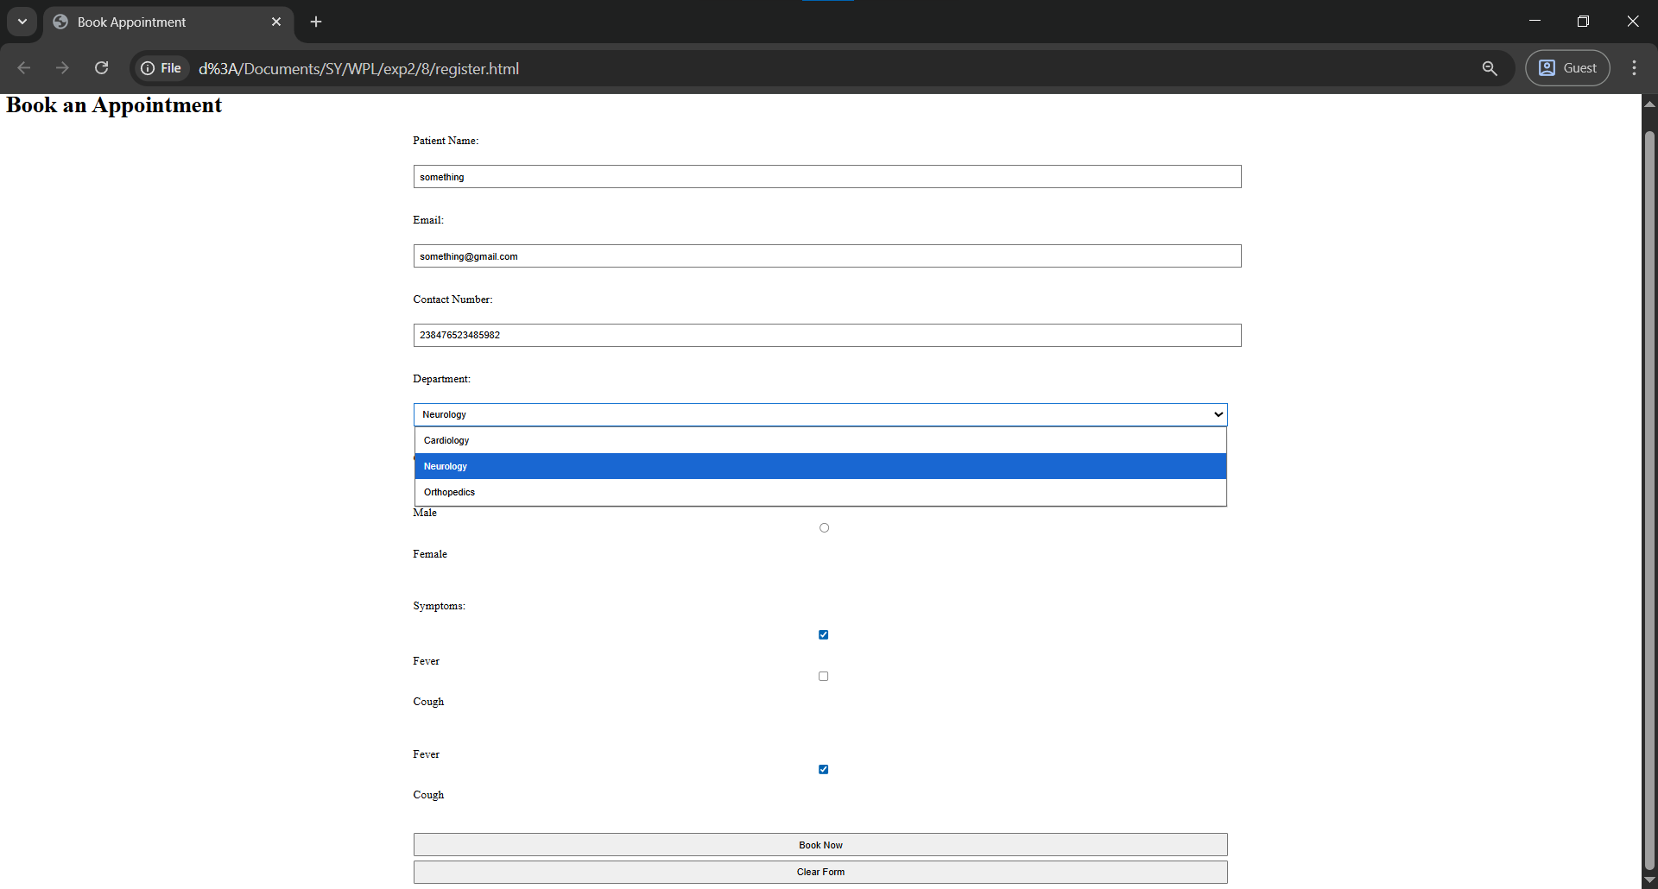
- Responsive Design
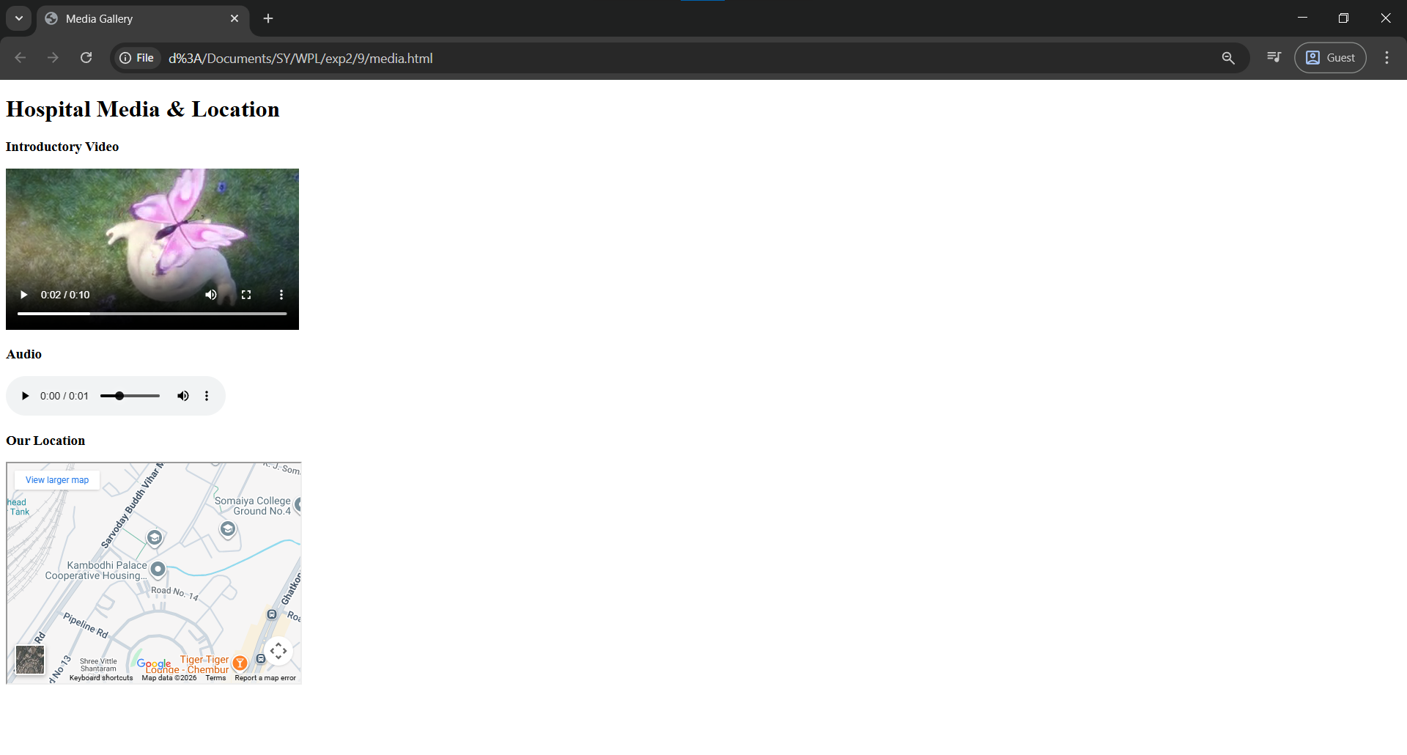

Post Lab Subjective/Objective type Questions:
- Write CSS code to create a responsive layout using Flexbox.
Ans: Flexbox helps arrange items in rows or columns and adjusts automatically for different screen sizes.

.container {
display: flex;
justify-content: space-around;
flex-wrap: wrap;
}
.box {
width: 200px;
padding: 10px;
}

- Write a media query for screens smaller than 768px.
Ans: Media queries change layout for mobile screens.
@media (max-width: 768px) {
body {
font-size: 14px;
}
}

- Justify the use of CSS animations in user interfaces.
Ans: CSS animations make the website more attractive and interactive.
They help users understand actions like hover, click, and loading without JavaScript.
Animations also improve user experience and visual feedback.

- Design a CSS animation for a call-to-action button.
Ans: This animation makes the button pulse to attract users.
button {
animation: pulse 1.5s infinite;
}

@keyframes pulse {
0% { transform: scale(1); }
50% { transform: scale(1.1); }
100% { transform: scale(1); }
}

- Create a responsive navigation menu using Flexbox and media queries.
Ans: Flexbox aligns the menu horizontally, and media query stacks it on mobile.
nav {
display: flex;
gap: 20px;
}

@media (max-width: 768px) {
nav {
flex-direction: column;
}
}

[1] MDN Web Docs, “CSS Flexible Box Layout,” Mozilla, 2024.
[2] W3Schools, “CSS Media Queries,” W3Schools, 2024.
[3] MDN Web Docs, “CSS Animations,” Mozilla, 2024.

Conclusion and Discussion:
(students should write in your words)
In this experiment, I learned how CSS3 is used to improve the look and structure of a web portal. I
understood how selectors, box model, Flexbox, tables, forms, and media queries work in real time as well as how CSS3 really makes the biggest contribution to beautiful webpages that color our day to day life bright

Drive link:
https://drive.google.com/drive/folders/1aAfJwENbwK1niF-72KCe3QYGHS_-ETRe?usp=sharing

(Also get feedback from fellow classmates (minimum 3) and faculty to add here)

Vedant: the form can really use a coloured background and the media one can have more things
Navjyot: the hospital is weird
Mohammad: department page can have more colors I think.

Faculty:

